Chapter 12, Solution 48.

- We first convert the delta load to its equivalent wye load, as shown below.

A
A

Z_{A}
18-j12 40+j15
Z_{B}

Z_{C}
B
C B C

60

` 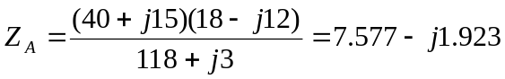
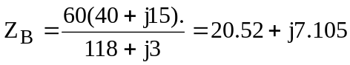
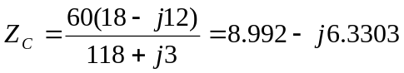
The system becomes that shown below.

a 2+j3 A

+
240<0º Z_{A}
-
I₁
- - Z_{B} Z_{C}
240<120º 240<-120º
+ + 2+j3
c I₂ b
B C

2+j3

We apply KVL to the loops. For mesh 1,
or

(1)
For mesh 2,
or

(2)
Solving (1) and (2) gives

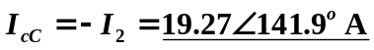

(b)

